**F20 COMP1111 Test 1 Tues October 13 M. Green**

**Name: Emanuel Dobra Mark: /45**

Save this file from Blackboard: **Music Lessons.accdb**

**Background information**

This database is about a music school where students may sign up for more than one class, and a contract is written up for each class they take. In other words, one student may have many contracts.



**New Record**

Add a new record to student table using your name. Make up remaining field values. ( /2)

**Relationships**

Create a relationship between the two tables. Enforce referential integrity/cascade updates.

( /3)

**Create Form**

Create a form named **frmStudent** for the Student table, putting your name in the title of the form. ( /3)

**Create Report**

Create a report named **rptContract** for the Contract table, typing ‘Created by: your name’ in the title of the report. ( /3)

**Create Table**

Create a new table named **Location-XX** (XX are your initials),

* you determine best field sizes and types for each field.
* type field names EXACTLY as shown
* assign LocationID as the primary key. ( /10)

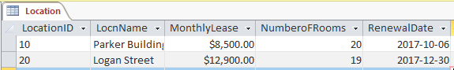

* type in the two records shown in the screenshot, (date may change format – that’s ok!) ( /3)

increase the font size of this table’s data to 14,

and make sure all field names and data are showing ( /2)

**Queries using Student table only:**

1. Include all fields. Display only records that have the letters SW anywhere in the address field. Sort alphabetically by Last Name.

Save query as Q1-XX (XX are your initials) ( /3)

1. Include all fields, display students whose last name starts with the letter ***B*.** Save query as Q2-XX(XX are your initials) ( /3)
2. Include first name, last name, city and gender fields. Display all male students living in the city of **Hillsboro**.

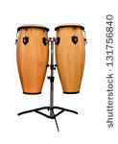Save query as Q3-XX (XX are your initials) ( /4)

**Query using Contract table only:**

1. Display ContractID, Lesson Type, and Monthly Lesson Cost. Only display records with a Monthly Lesson Cost of $120 or more. Sort by Monthly Lesson Cost, highest to lowest.

Save query as Q4-XX (XX are your initials) ( /3)

**Query using Student and Contract tables:**

1. Include lesson type, last name, first name, and contractID.

Display only records where the lesson type is Voice. Don’t display lesson type in the query’s results. Sort alphabetically by last name.

Save query as Q5-XX (XX are your initials) ( /3)

**All done?**

* Close your database – very important!
* Submit to Blackboard – 1) your completed database file, and

2) this WORD document with your name typed at top

Please note: you’ll only have one chance to submit work to submit files to Blackboard, so make sure you’ve put in the correct ones!